Cladtek was contracted by Wood, a multinational energy services company to produce 30” CRA pipe spools and assembly structure for Exxon Mobil PNG LNG. The pipe spools required pre-assembly and dimensional survey providing a turnkey solution, installed into existing process piping during a plant shutdown.

To ensure smooth onsite installation Cladtek fabricated the 30” pipe spools with a very precise assembled tolerance of 3mm based on the existing tie in points located over 30m apart. Cladtek’s scope of work included engineering design, procurement of rigging and lifting gear, procurement of carbon steel, structural and piping fabrication, pre-assembly, dimensional survey, painting and thermal spray aluminum coating. The complete scope was performed in house.

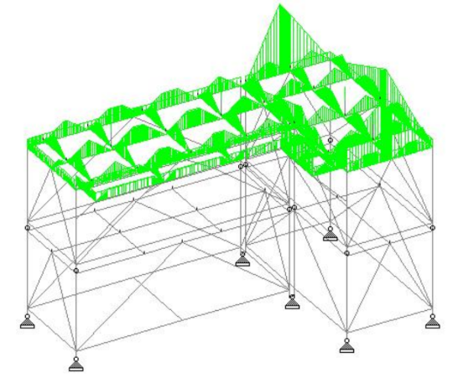

Staad Pro design output for 50 year earthquake event

Cladtek designed and fabricated a support structure to enable to pre-assembly to take place in Cladtek’s Batam facility. This same support structure was then transported to site in Papua New Guinea and utilized for the final installation. The structure was designed for easy shipment, modular installation and to withstand 50 year earthquake and cyclone events. The design calculations were completed in house using Staad Pro software. The structural design was in accordance with AISC, AWS and AS standards.

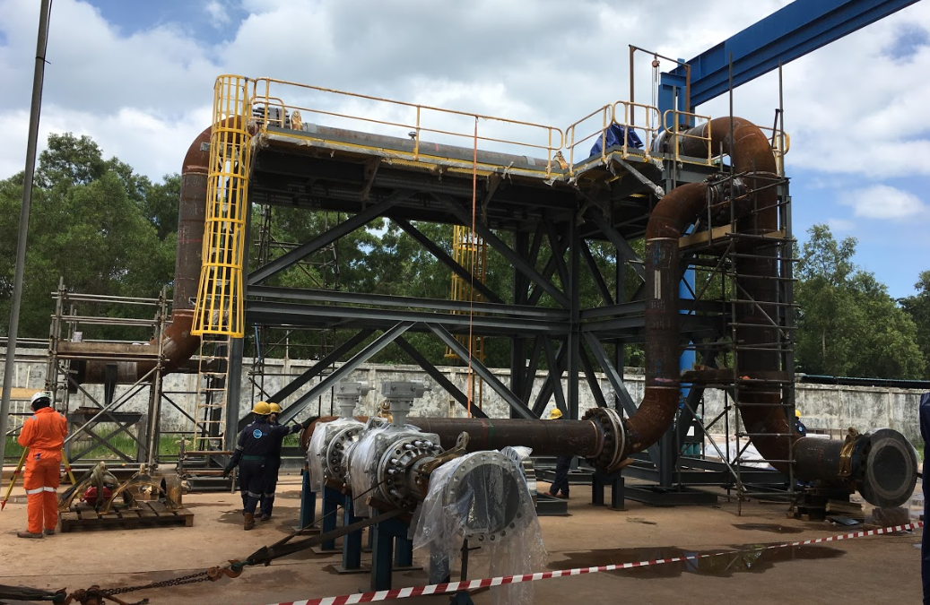

Pre-Assembly at Cladtek Batam, Indonesia facility

The pipe support structure was pre-assembled in Batam, Indonesia along with the pipe spools as shown above. The assembled pipe spools were surveyed and the final tie in flange field welded on site to ensure the tight tolerance of 3mm for the tie in points were complied with. The survey was presented on a 3D model as shown below for easy interpretation and evaluation.

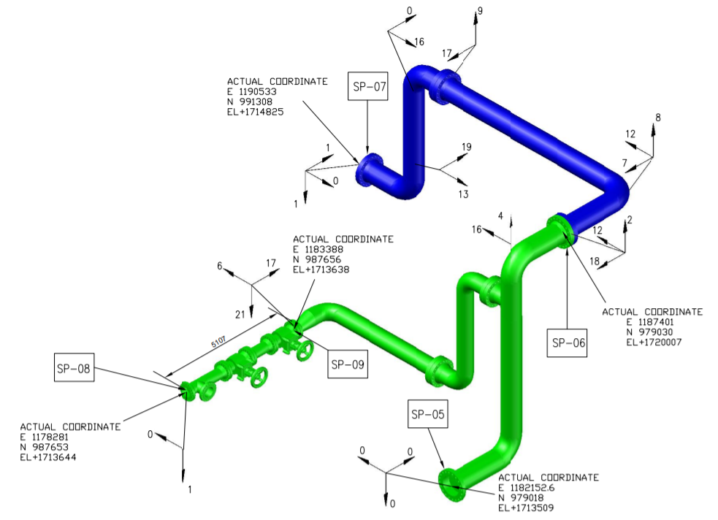

3D pipe spool survey results

Following successful survey of the pre-assembled pipe spools, hydrotest and leak test was successfully conducted. The spools were painted and protected with specially fabricated flange protection plates to ensure safe transportation to site in PNG. Cladtek also designed shipping skids with lifting gear for the pipe spools that were not able to fit inside a conventional shipping container.

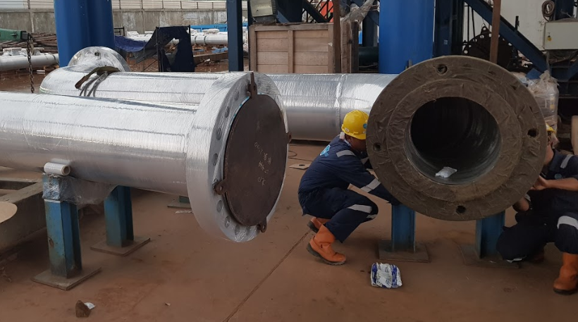

Packing and preservation prior to shipping.

A trail assembly of the structure and pipe spools was conducted on site in PNG prior to the plant shutdown, the pre-assembled pipe spools were again surveyed and dimensional tolerance confirmed compliant prior to installation. The on-site trial assembly is shown below.
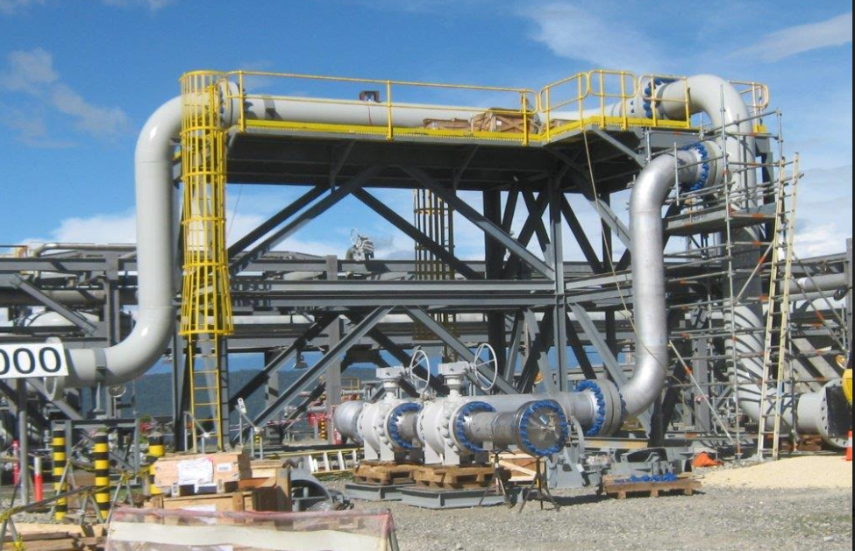

Pre-Assembly on site in PNG prior to installation

Pipe spools were then permanently installed and leak tested during the plant shutdown within the planned timing window. Photos of the installation process and final tie in points are shown to the right. The successful completion of the complete scope of work in house demonstrates Cladtek’s technical, manufacturing and fabrication ability. In addition to showcasing Cladtek’s “One Stop Shop” making life simple and stress-free for clients.

For more information, please contact us at info@cladtek.com

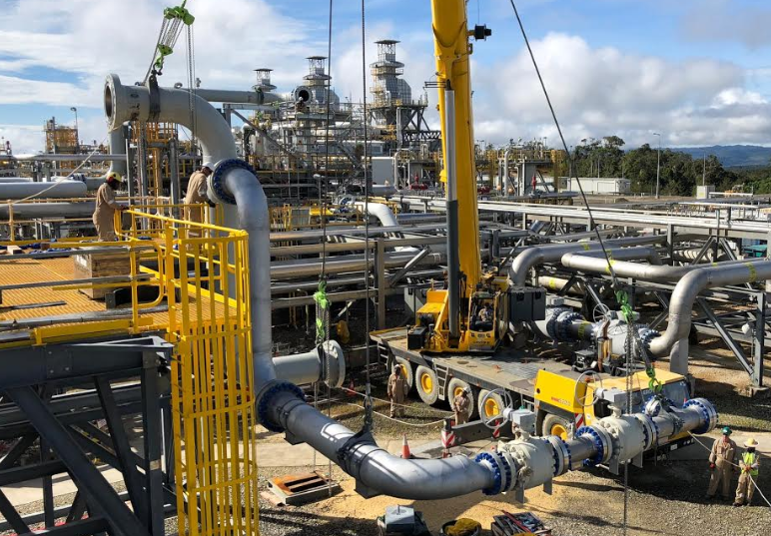

Lifting pipe spools into final location in PNG

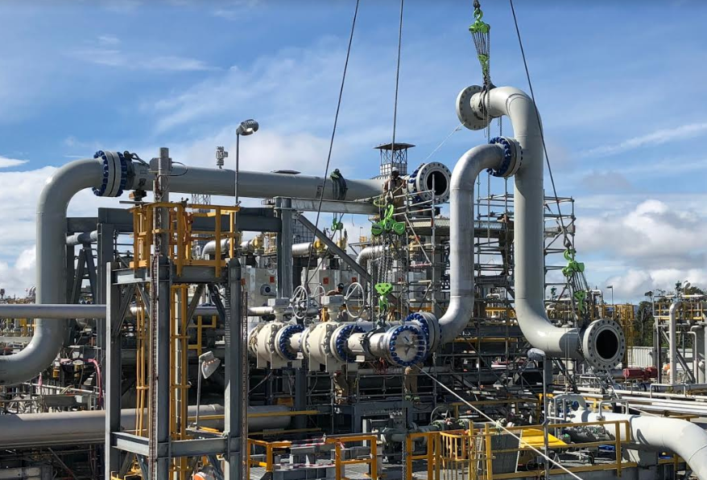

Lifting pipe spools into final location in PNG

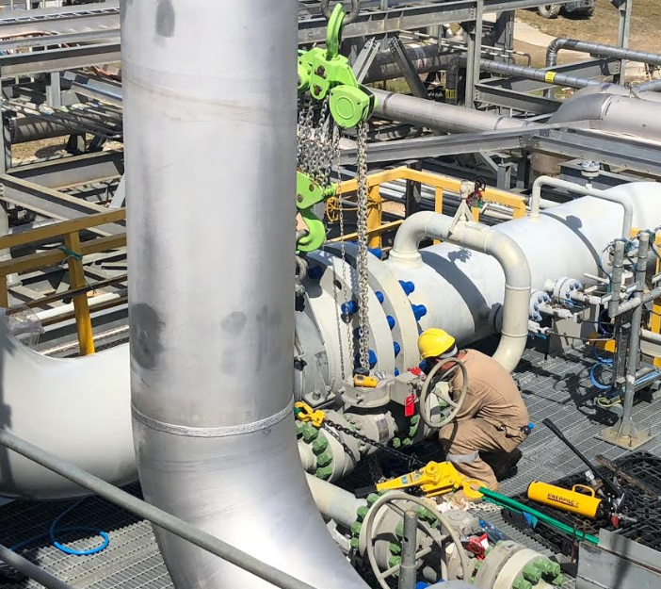

Final tie in point to existing pipework

