Cladtek has successfully completed manufacture of over 21km of 24” diameter Mechanically Lined Pipe (MLP) for Mobil Producing Nigeria (MPN), an Exxon Mobil subsidiary. The pipe is to be installed subsea at MPN’s Idoho field, and at 24” diameter will be the largest diameter mechanically lined pipe installed anywhere in the world.

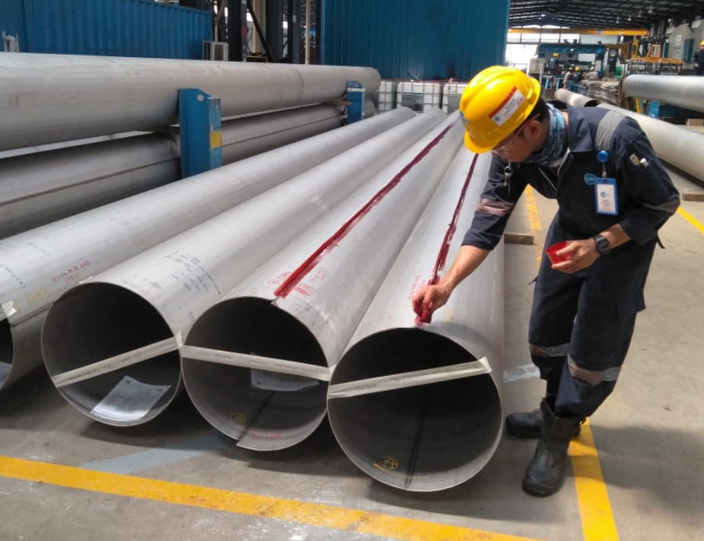
The delivery represents an outstanding achievement for Cladtek and MPN. Being a world first, the project faced a number of challenges but a highly cooperative approach between project stakeholders Cladtek, Mitsui, Delta Afrik and MPN, coupled with innovative thinking and strong technical knowhow assured successful outcomes.

Cladtek utilized its patented hydro-expansion process to manufacture the MLP. Cladtek also used its newly designed and implemented laser seal welding system enhancing both production rates and product quality.

Double long seam CRA liner for World’s Largest MLP -
-
As part of the project, Cladtek also supplied over 2km of 24” weld overlaid pipe, induction bends, and integrated riser hanger flange assemblies. Cladtek’s unique one-stop-shop offering in the CRA cladding arena provided significant advantages to our customer, as all works were carried out in-house at our Batam facility.

Cladtek has a strong track record in manufacture and delivery of MLP, and had previously supplied the world’s largest diameter MLP at 22” installed in deepwater at the Liwan field in the South China Sea.

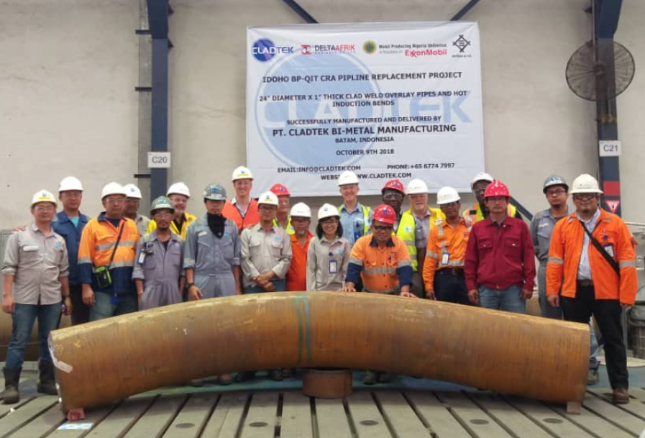
Cladtek has continued to develop its MLP technology and capabilities and has now added significant MLP manufacturing capability at its purpose built plant in Brazil. Cladtek is a global leader in the manufacture and supply of MLP and has its own in-house bend testing capabilities for MLP at its Batam facility. Cladtek recently manufactured MLP that underwent full scale fatigue testing for fatigue loading. This simulated the most severe service dynamic applications, as a result Cladtek MLP has achieved industry leading results for high stress, high fatigue conditions achieving DNV Class C for OD transition points and Class D for ID transition points. Delivery of final 24" Induction Bend on schedule

For more information, please contact us at info@cladtek.com

